AskMe Download and Installation Guide

Here in this section, we will discuss how to set up the project to start using the application.

## 1. Download and Install required softwares

### **Java**



Download and install JDK 1.8 for the OS type

<https://www.oracle.com/java/technologies/javase/javase-jdk8-downloads.html>

### **Intellij IDEA**



Download and install Intellij IDEA Ultimate Edition 2019.3 and above

<https://www.jetbrains.com/idea/download/#section=windows>

### **Node.js**

Download and install NodeJS appropriately for the OS

<https://nodejs.org/en/download/>

### **NPM**

Download and install NPM appropriately for the OS

<https://www.npmjs.com/get-npm>

### **Plugins & SDK**

Open Intellij IDEA, ***File->Settings*** and ensure that the following plugins are installed.

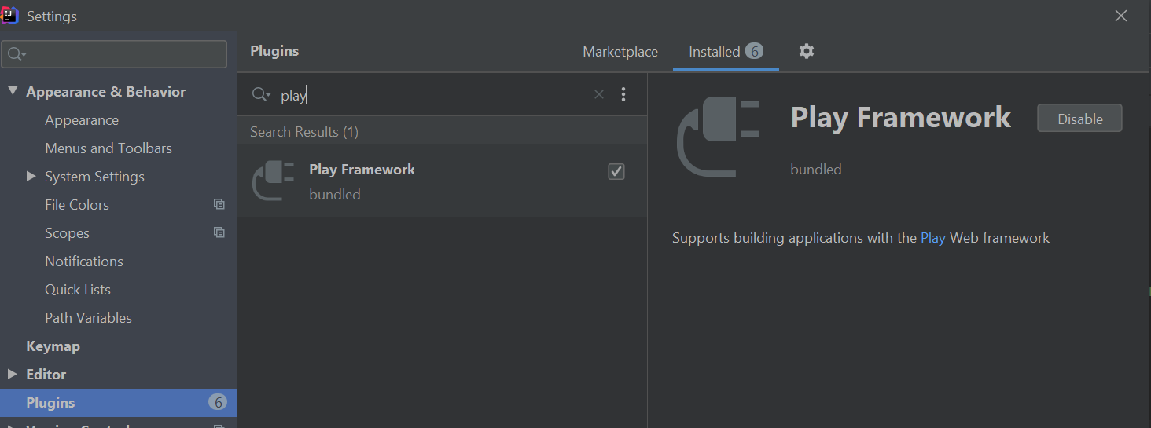

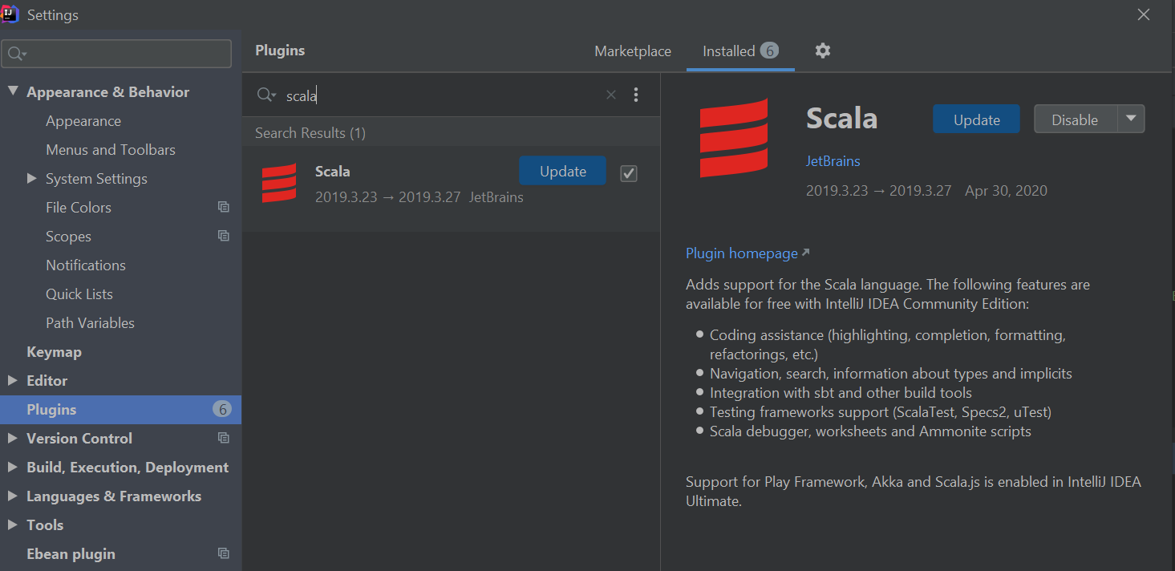

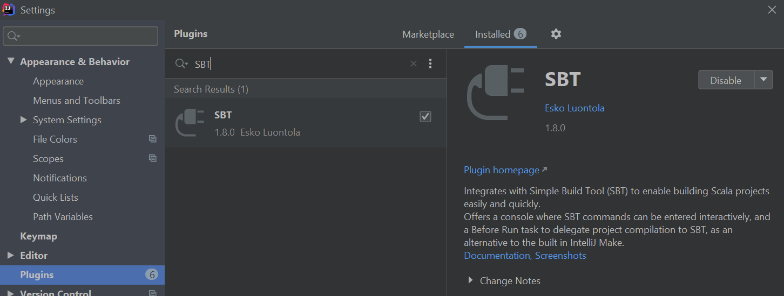

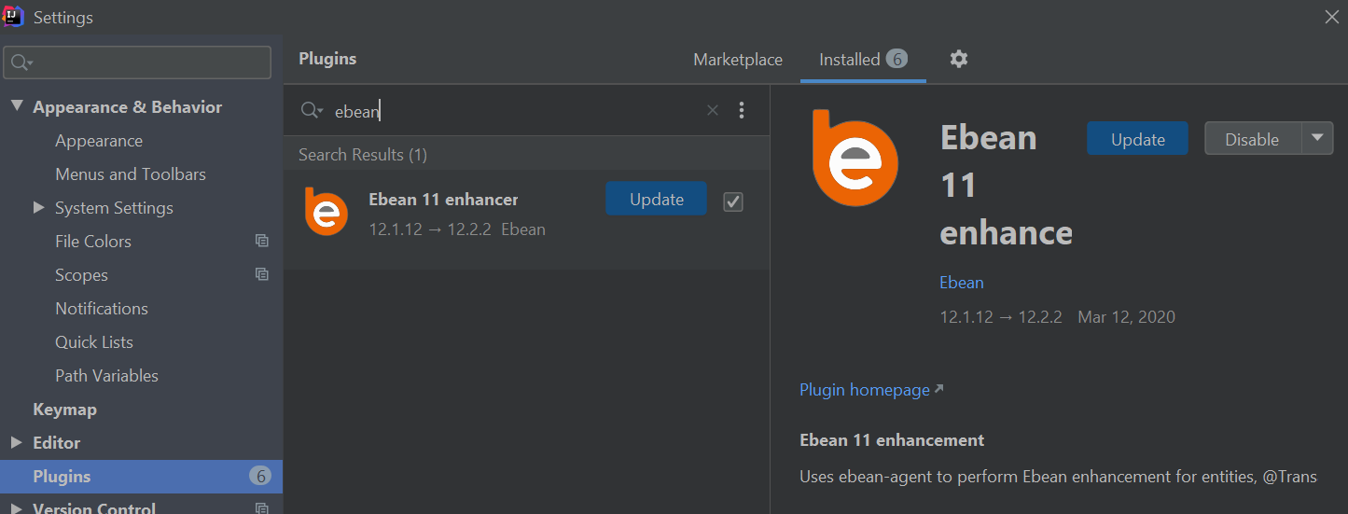

Ensure that sdk is appropriately set to 1.8, ***File->Project Structure***

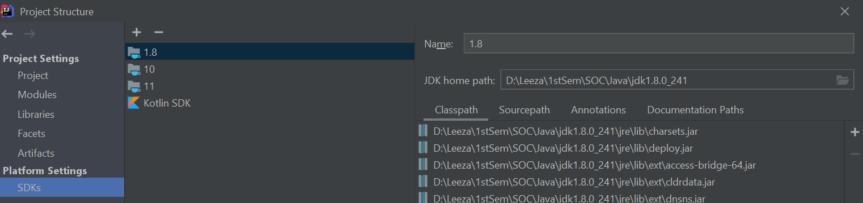

### 

## 2. Download/Setup & StartUp Application

* + The website codebase is available at the following github location:

[https://github.com/jiazhang-class/18653-Team8](https://github.com/jiazhang-class/18653-Team8.git)

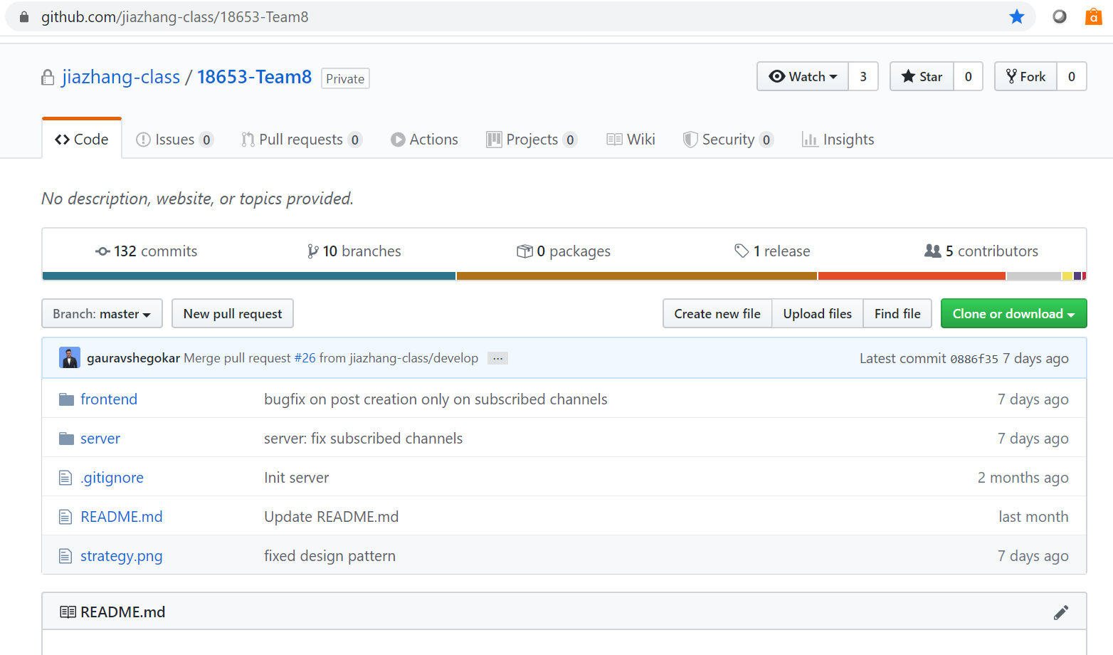

* + The codebase can be cloned via the git command line tool

**git clone** <https://github.com/jiazhang-class/18653-Team8.git>

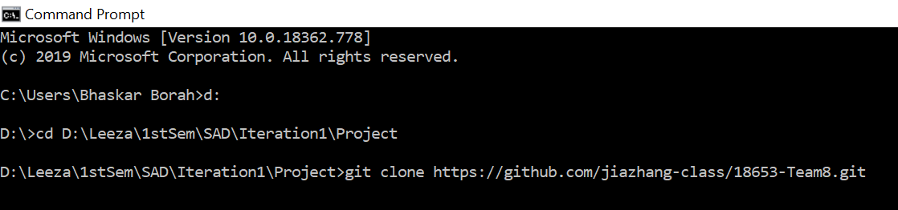

* + Or via the browser

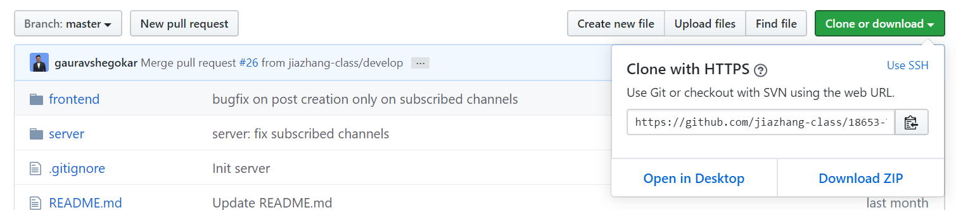

* + Or via any github desktop applications like SourceTree.

***File -> Clone/New***

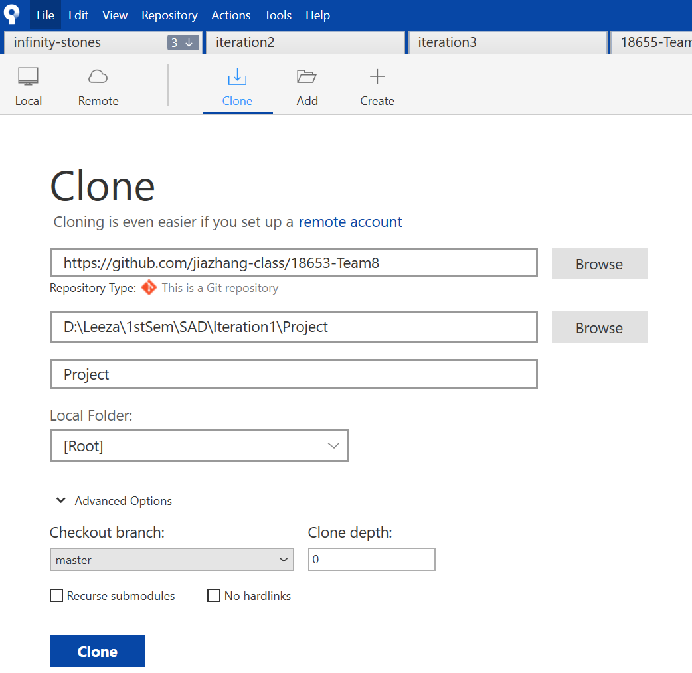

* + The codebase has two separate folders (projects) for frontend and backend named as follows

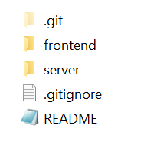

### 

## 3. FrontEnd project set-up/startup

* + Open Intellij IDEA , ***File-> Open*** the ***frontend->ask-me*** folder

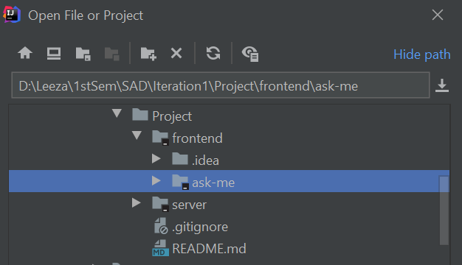

* + Wait a few moments for the project to load and indexing to complete

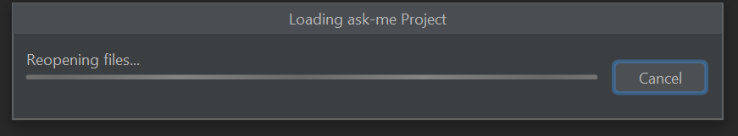



* + Once done, verify the project structure:

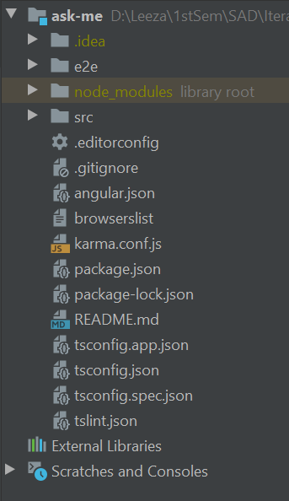

* + Navigate to ***ask-me*** folder on ***terminal*** (in INTELLIJ IDEA)and execute the following command to download and install the required project modules

***npm install -g @angular/cli***

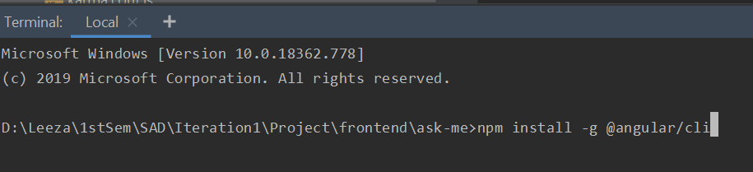

* + Once done, start the server by executing the following command from the same location:

***ng serve -o***

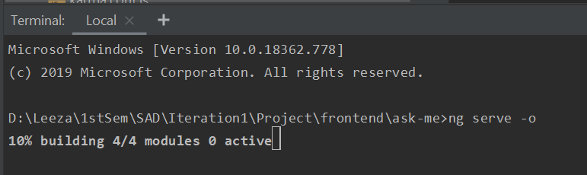

* + This should take a few moments to compile and start the application.
  + The application startup can be monitored from the ***Run*** window:

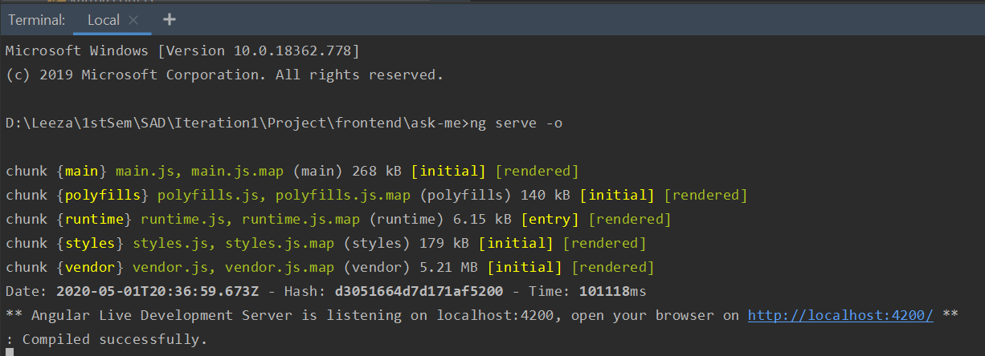

* + The home page of the application should load automatically in the default browser on the url :<http://localhost:4220>

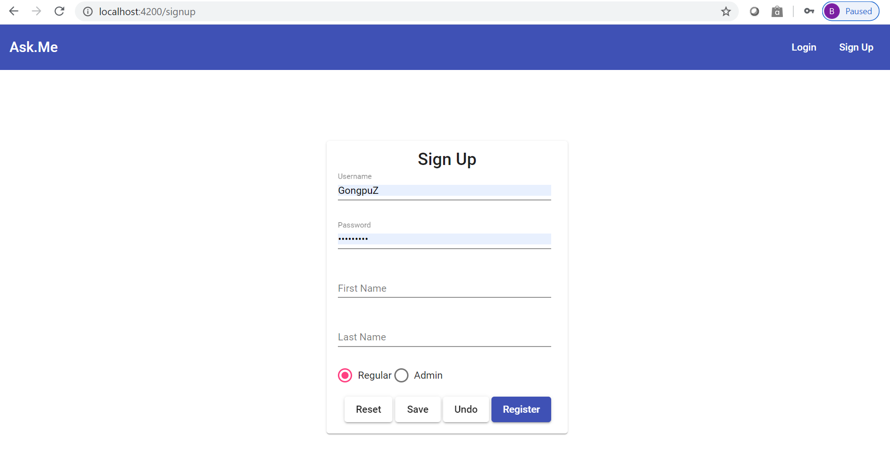

* + Do not start navigating the application yet because we still have the backend server to setup & start

### 

## 4. Server (Backend) project setup/start

* + Open Intellij IDEA , ***File-> Open*** folder ***server***

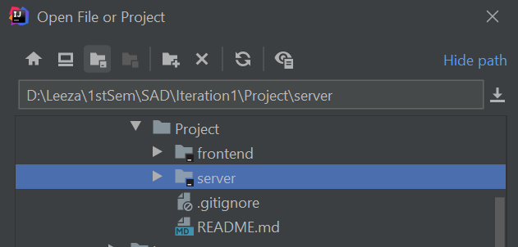

* + This will take about a minute to load the project, index files, download/sync sbt dependencies etc. While this happens go ahead and create the database schema









* + Create a database/schema in mysql
    - Can use mysql shell for database creation

***CREATE DATABASE sad***

* + - Or can execute the command from MySql workbench command line tool

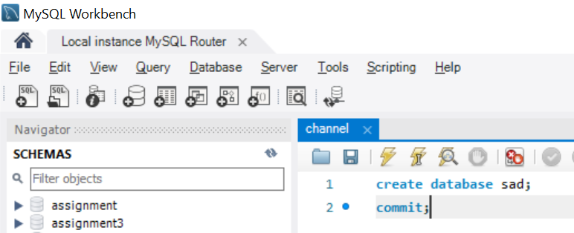

* + - Or create a new view from MySql workbench

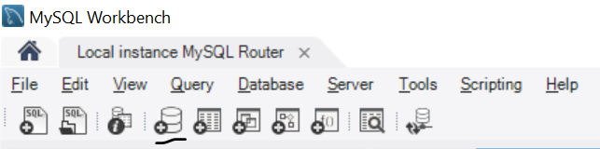

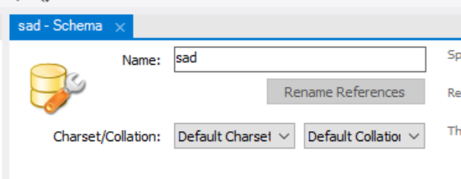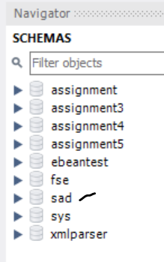

* + The project in Intellij should now be available for edit and configurations.

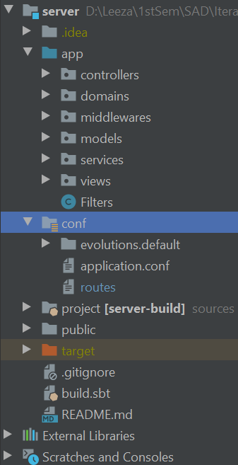

* + Open file ***conf/application.conf*** and update the database connection details and credentials to match the local environment

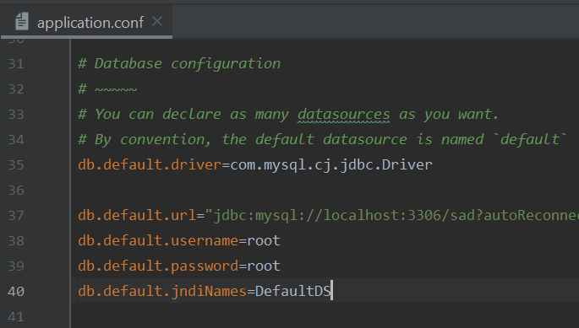

* + Goto file ***conf/routes*** andupdate the value of the following parameter to reflect the number of posts one wishes to be displayed on the feed page.

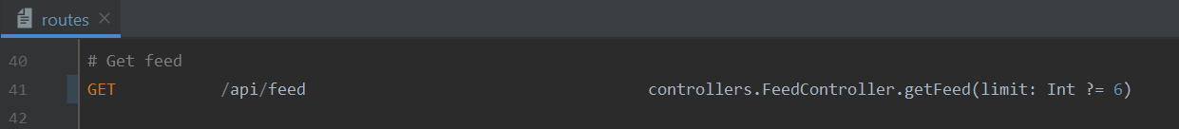

* + The application can be started in either of the following two ways:
    - SBT SHELL
      * Open SBT Shell and wait for a few moments to allow initialization

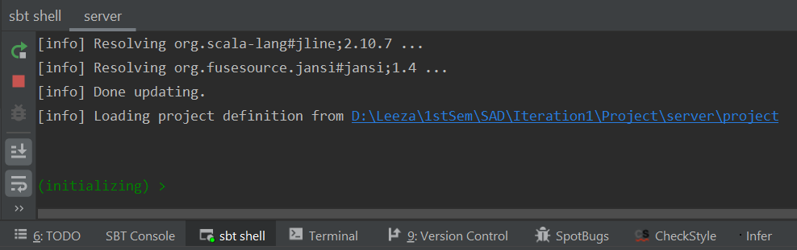

* + - * Run clean

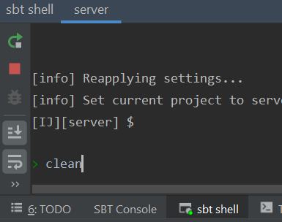

* + - * Once done, execute the following command

***run <desired-port>*** (recommended : 9000)

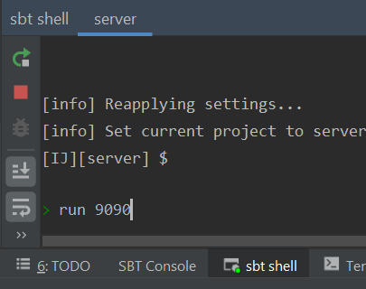

* + - RUN as PLAY APPLICATION
      * GOTO ***Run -> Edit Configurations***
      * Select ***+ -> PLAY APPLICATION***
      * Edit the following fields with the mentioned values

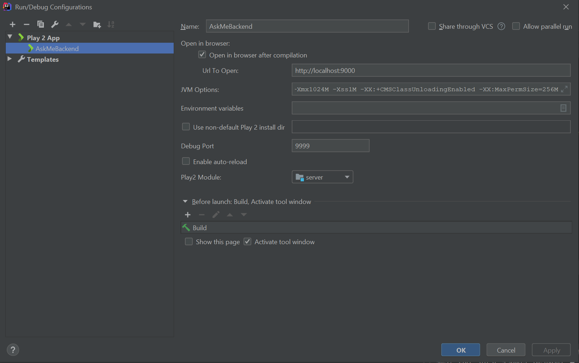

* + - * Click ***Apply***
      * Now, run the application by clicking the following button

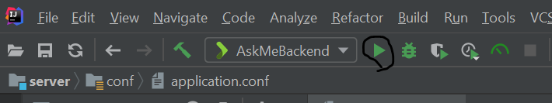

* + The application startup can be monitored from the ***Run*** windows :

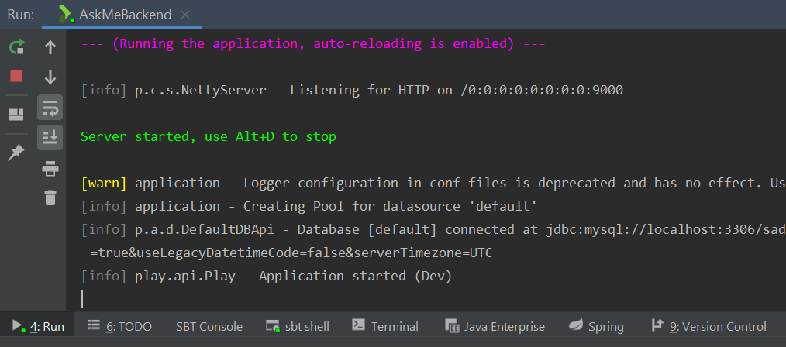

* + Somewhere during startup the default web browser will open up with the following page, prompting the user to “Execute Evolution”

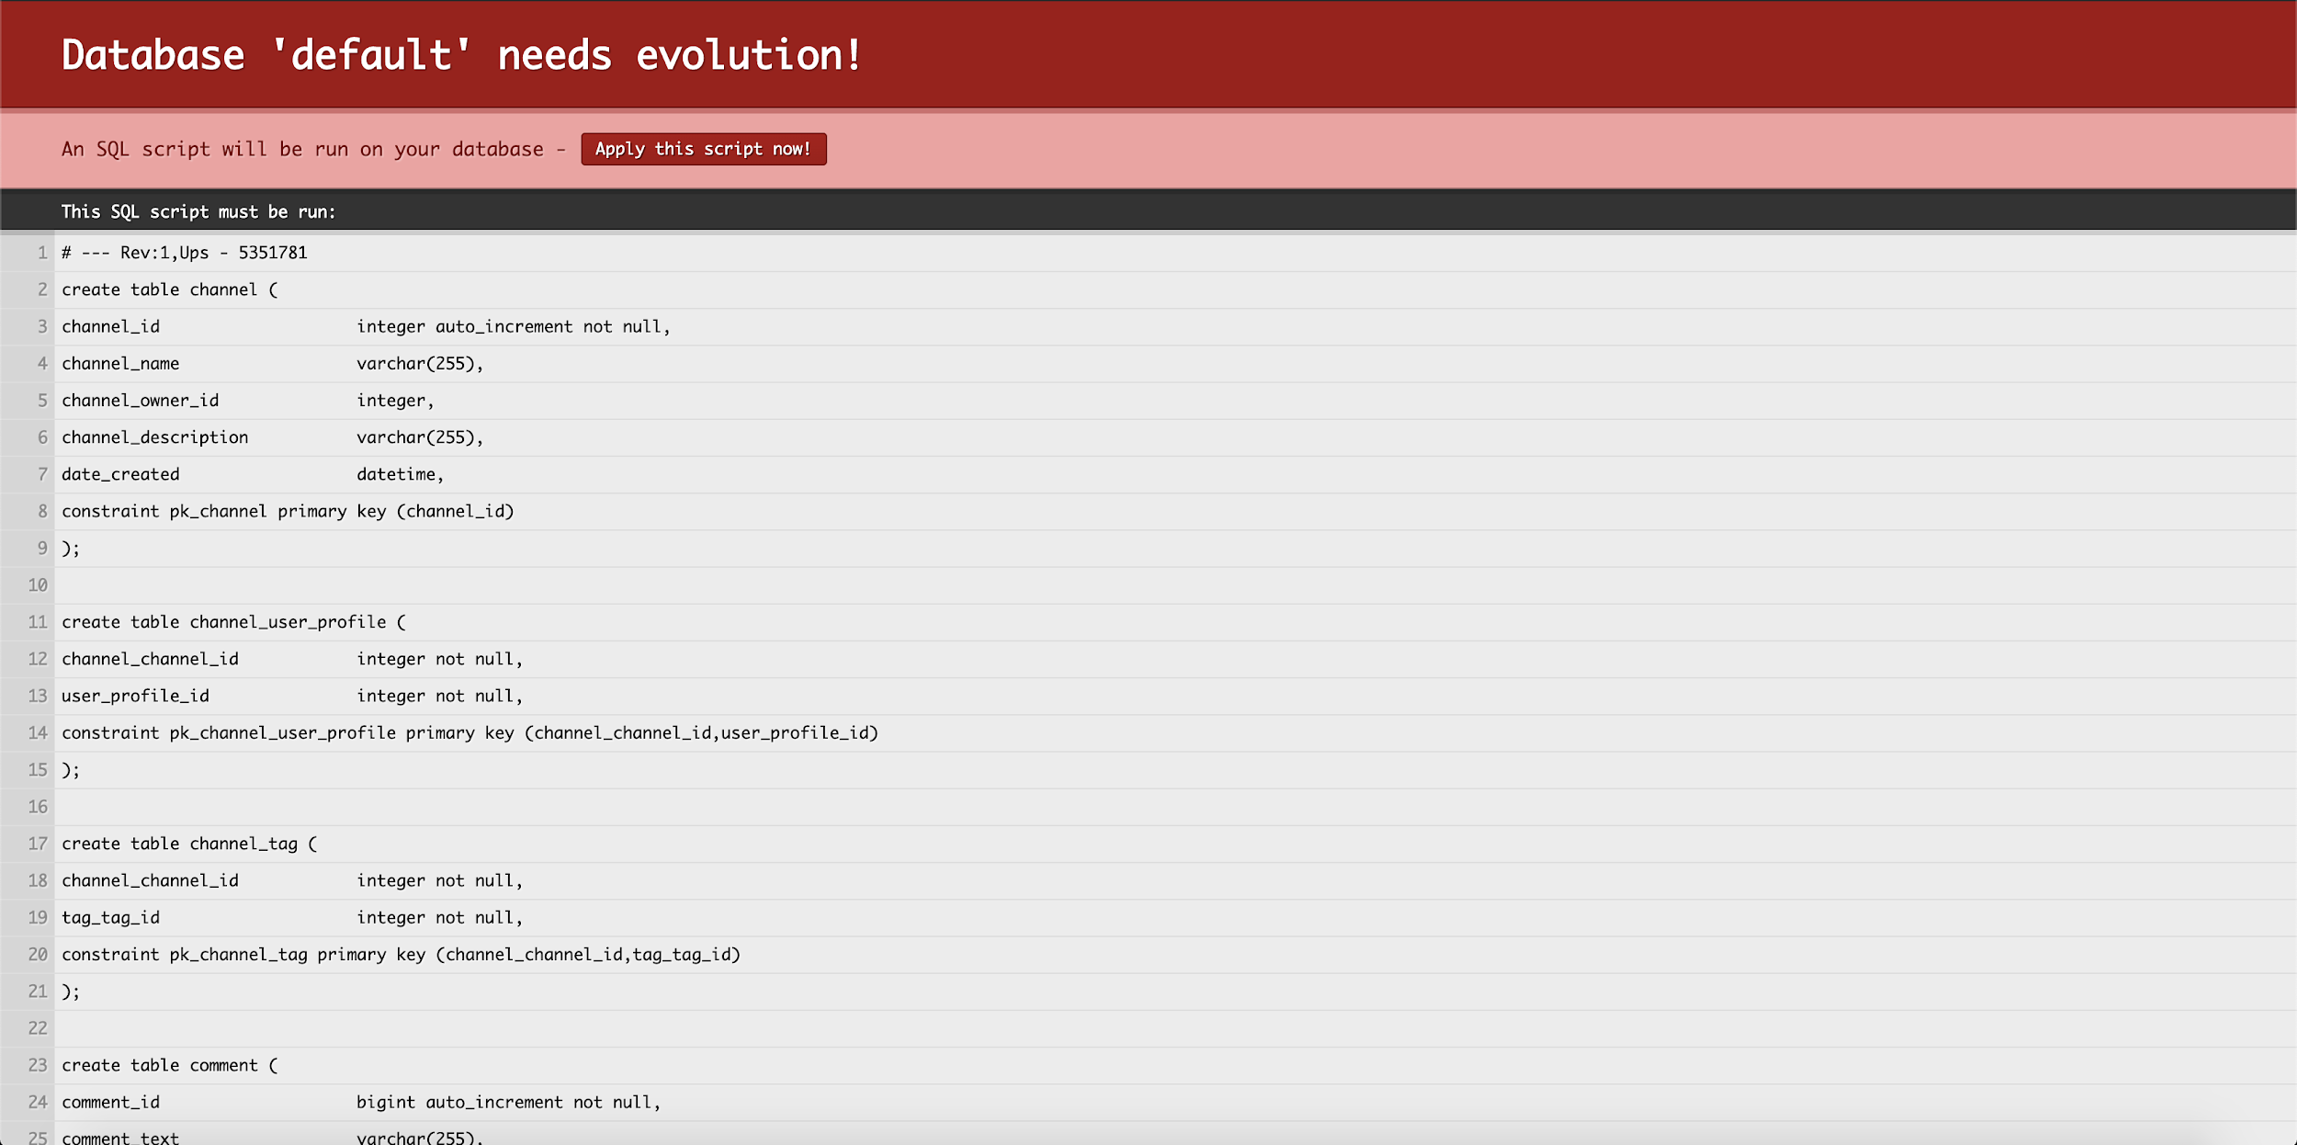

* + Click on the button to allow DB Evolution to execute, this might take a few moments.
  + Once done, verify the database to ensure that the following tables have been created.
    - Verify the tables

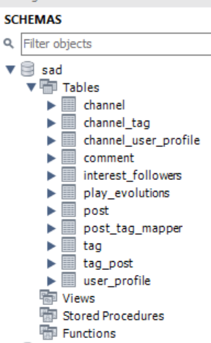

* + - Verify the data

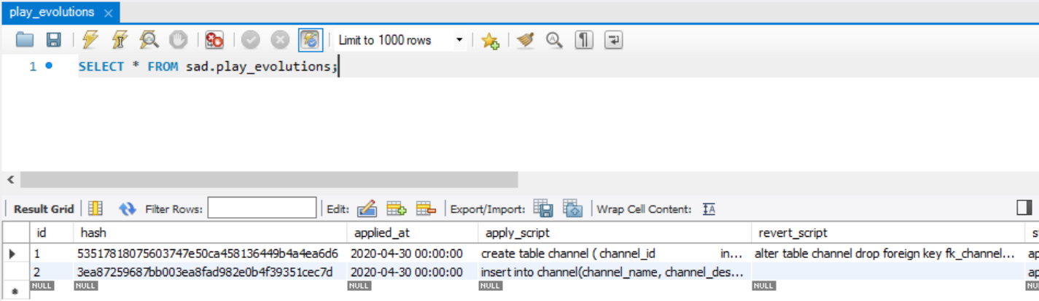

* + - Verify the ER Diagram

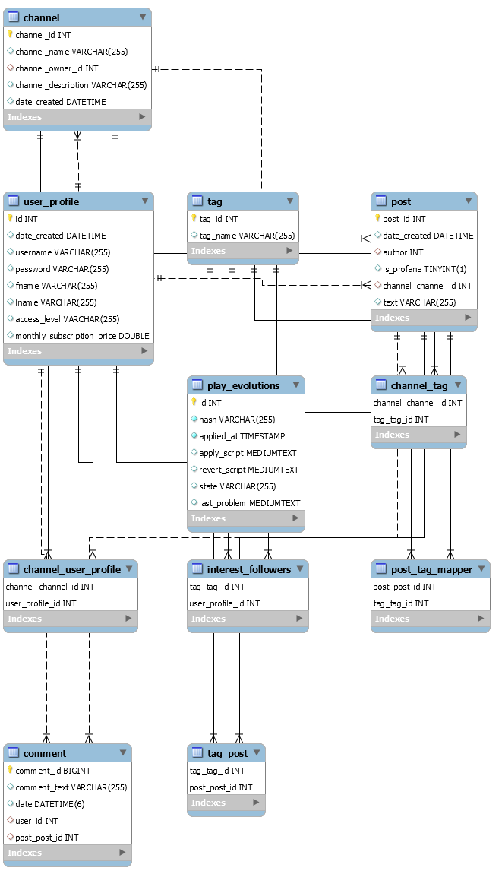

* + Once the DB evolution completes, the backend application will start on the browser with the following default page.

[http://localhost:9000](http://localhost:4220)

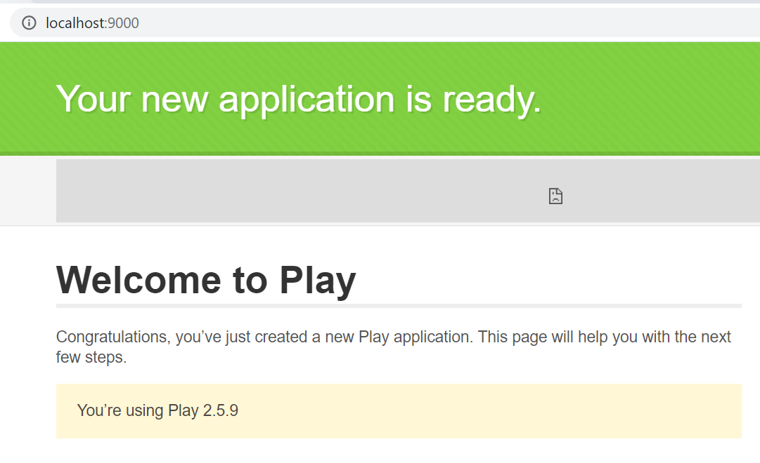

* + Navigate back to the front end application on the url

<http://localhost:4220>